  ___________________________________________________________________________________________

**“The only difference between death and taxes is that death doesn’t get worse every time Congress meets.”** – Will Rogers

**__________________________________________________________________________________________________________________________**



Will Rogers was spot on. This year’s tax preparation promises to be more complicated and painful than the last. In addition to the “advertised income tax brackets” in IRS literature, the Alternative Income Tax continues to hit more middle-income taxpayers whose income exceed modest thresholds, as well as squeezing out dollars from legitimate itemized deductions and personal exemptions. Last year’s additional Net Investment Income Tax (imposed to fund Obamacare) on “high income earners” layers an additional 3.8% to net interest, dividends, capital gains, rent, royalty and non-qualified annuity income. Also introduced last year was the .9% Medicare Surtax on wage earners whose joint wages exceeded certain thresholds which required careful allocation in the case of multiple employers during the tax year.

According to Kiplinger.com Obamacare further complicates the filing of 2014 tax returns.

On 2014 tax returns, Obamacare mandates are monitored, and penalties for noncompliance will be enforced for the first time. Taxpayers will need to document their monthly coverage, and indicate whether an employer provided coverage, or whether you opted out of an employer’s plan to purchase coverage in the marketplace. You may be eligible for premium tax credits if your employer’s lowest-cost plan exceeded 9.5% of your 2014 income. If you receive Form 1095-C from your employer, use this form to calculate whether you are eligible for the premium tax credit.

If you received subsidies in 2014 reducing your cost of coverage purchased through the marketplace, you will receive Form 1095-A which contains the information necessary for comparing the subsidy received to the computed eligible amount in order to determine whether some of your advanced credit was higher or lower than your eligibility (triggering a refund to you – or requiring your repayment to IRS).

Although there are several penalty exemptions, if you were uninsured for some or all of 2014, you may have to pay a penalty of the higher of $95 per person or 1% of your household income above the applicable threshold.

In 2015 the penalty increased to the higher of two amounts: the basic fine up to $325 per uninsured person or an income-based levy of 2% of household income exceeding the applicable threshold.



**Audit Red Flags**1

The chances of being audited increase upon various factors including your income level, the types of deductions or losses claimed, the business in which you’re engaged and whether you own foreign assets.

**Income level:** IRS statistics for 2013 show that one in every 30 returns were audited for people with incomes of $200,000 or more; and one in every 9 returns were audited for incomes of $1,000,000+. But only .88% of returns with income below $200,000 were audited during 2013, and the vast majority of those were conducted by mail.

**Taking disproportionately large charitable deductions compared to your income.** Also, if you don’t get an appraisal for donations of valuable property, or if you fail to file Form 8283 for noncash donations over $500, you are an audit target.

**Claiming Rental Losses:** Normally, the passive loss rules prevent the deduction or rental real estate losses. But there are two important exceptions. If you actively participate in the renting of your property, you can deduct up to $25,000 of loss against your other income. But this $25,000 allowance phases out as adjusted gross income exceeds $100,000 and disappears entirely once your AGI reaches $150,000. A second exception applies to real estate professionals who spend more than 50% of their working hours and 750 or more hours per year materially participating in real estate as developers, brokers, and landlords. They can write off losses without limitation.

**The IRS is actively scrutinizing rental real estate losses, especially those written off by taxpayers claiming to be real estate professionals.** For the past several years, the IRS has pulled returns of individuals who claim they are real estate professionals and whose W-2 forms or other non-real estate businesses show lots of income. Agents are checking to see whether these filers worked the necessary hours, especially in cases of landlords whose day jobs are not in the real estate business.

**Deductions for Business Meals, Travel and Entertainment** are always ripe for audit. To qualify for meal or entertainment deductions, you must keep detailed records that document each expense dollar amount, the venue, the people attending, the business purpose and the nature of the discussion or meeting.

**Claiming 100% Business Use of a Vehicle:**

If you depreciate a car, you must list on Form 4562 what percentage of its use during the year was for business. Claiming 100% business use of non-commercial vehicles raise a red flag. Make sure to keep detailed mileage logs and precise calendar entries documenting the purpose of every road trip. And remember if you use the IRS’ standard mileage rate, you can’t also claim actual expenses for fuel, maintenance, insurance or other out-of-pocket expenses.

**Deducting Losses for Hobby Activities:**

You are required to report any income earned from a hobby, but cannot deduct a net loss from the activity. To claim a loss, the activity must be entered into and conducted as a business with the reasonable expectation of making a profit.

If your activity generates profit 3 out of every 5 years (or 2 out of 7 years for horse breeding), it is presumed to be a business, unless IRS finds

otherwise. Make sure you run the activity following all business protocol and maintain supporting documentation for all expenses.

**Running a Cash Business:**

IRS statistics show that those who receive primarily cash are less likely to accurately report all their income. Thus IRS agents are specially trained in targeting and interviewing small business owners in cash-intensive activities such as taxis, car washes, hair and nail salons, bars and restaurants.

**Failing to Report a Foreign Bank Account:**

The IRS is intensely interested in people with money stashed outside the U.S., especially in tax havens, and tax authorities have had success getting foreign banks to disclose account information. The IRS has also used voluntary compliance programs to encourage folks with undisclosed foreign accounts to come clean – in exchange for reduced penalties. The IRS has learned a lot from these amnesty programs and has been collecting billions of dollars for their efforts! Failure to report a foreign bank account can lead to severe financial and/or criminal penalties. You must electronically file FinCEN Form 114 by June 30 to report foreign accounts that total more than $10,000 at any time during the previous year. Additional separate forms and disclosures may be required, depending on whether you own other foreign assets or an offshore business interest.

*“All taxes discourage something. Why not discourage bad things like pollution rather than good things like working or investment?” – Lawrence Summers*

**The New Rules of Estate Planning** are summarized in an October 24th Wall Street

Journal article by Laura Saunders: “The federal estate tax is no longer the biggest concern for most affluent people who want to avoid taxes on wealth they leave to heirs.”

In 2013 Congress reset the top estate-and-gift tax rate at 40% and raised the exemption to $5 million per person with annual inflation adjustments. For year 2015 the estate and gift tax exemption is $5,430,000; while the annual gift tax exclusion remains at $14,000 per donee.

The new rules present tax-saving opportunities that many people planning estates remain unaware of – and that could contradict past advice. “The conventional wisdom has been turned on its head because of changes in both the income tax and the estate tax,” says Suzanne Shier, chief tax strategist at Northern Trust in Chicago.

In the past, for example, avoiding onerous estate tax rates entailed a trade-off of minimizing long-term capital gains taxes which had a much lower 15% rate. But now many people who have estate values below the current $5.43 million exemption can glean substantial tax savings on capital gains by holding assets until death. This holding strategy is becoming more advantageous as the top federal capital gains rate increased last year to 23.8% - and there is some chatter about raising it to 28% plus any state capital gains could be added on top.

We recommend that estate plans are reviewed for those with values falling below the federal estate tax exemption.

**Reset Capital Gains**

The federal code has long had a provision, known as the “step-up,” that cancels the long-term capital gains tax on assets that a taxpayer

holds until death. The step-up automatically raises the owner’s cost basis for such assets – the starting point for measuring a taxable gain – to its full market value as of the date of death.

This new focus on the “step-up” may prompt reversing courses in many estate plans.

For example, say an investor bought a piece of land or stock shares many years ago for $20,000, and the value has grown to $200,000. If the investor sells the asset before his death, he will owe capital-gains tax on the $180,000 profit, at a rate as high as 23.8% (the top 20% capital gains rate, plus a surtax of 3.8%).

If the investor holds the same asset until death, however, the capital-gains tax vanishes. The asset will be included in the owner’s estate at full market value, sheltered by an estate-tax exemption currently set at $5.34 million (reduced by his previous taxable gifts, if applicable).

This move is especially important in high-tax states such as California, where the top combined federal and state capital-gains rate exceed 35%.

**Tap the Right Assets**

To meet cash needs, it may even make sense to take out a loan rather than selling appreciated investments in taxable accounts, especially with current interest rates so low.

Another consideration is to make withdrawals from traditional retirement accounts. Because of the tax-deferred nature of the accounts, they won’t receive a step-up in basis at death, although they do trigger ordinary income tax rates, which are higher than capital-gains rates.

**Revisit Your Trusts**

While there remain non-tax reasons for having a trust (if one spouse is a non-U.S. citizen, or to direct complex distributions of assets, and privacy are key reasons), the new provision known as “portability” may replace the need for those trusts established solely for the purpose of utilizing estate-tax exemptions of both spouses.

Now a surviving spouse can claim the unused portion of a deceased spouse’s exemption. Thus if spouse #1 dies and leaves $1 million to the children, the surviving spouse can utilize the remaining $4.34 million exemption, adding to the survivor’s full exemption available at the 2nd death. [NOTE: the surviving spouse must file Form 706 with IRS within nine months of death in order to qualify the claim for the decedent’s unused exemption].

In fact, many couples that had tax-savings trusts set up years ago may actually raise taxes for their heirs. For example, if a spouse leaves a $1.5 million estate to a trust under the terms of a 2005 will designed to protect the estate tax exemption amount in that year, then there will be no step-up on the subsequent growth of the assets. But if the decedent left the same assets directly to the spouse, future growth could escape capital-gains tax at the 2nd death.

**Reconsider Gifting**

For most couples’ estate planning, there’s almost no reason to make gifts anymore. Unless there’s an estate value exceeding their joint $10.68 million exemption (reduced by previous reportable gifts), it’s better to save heirs’ future capital-gains taxes.

Lifetime gifts retain the donor’s cost basis, forfeiting any “stepped-up” basis to donees.

**Beware of State Taxes:** (see chart below)

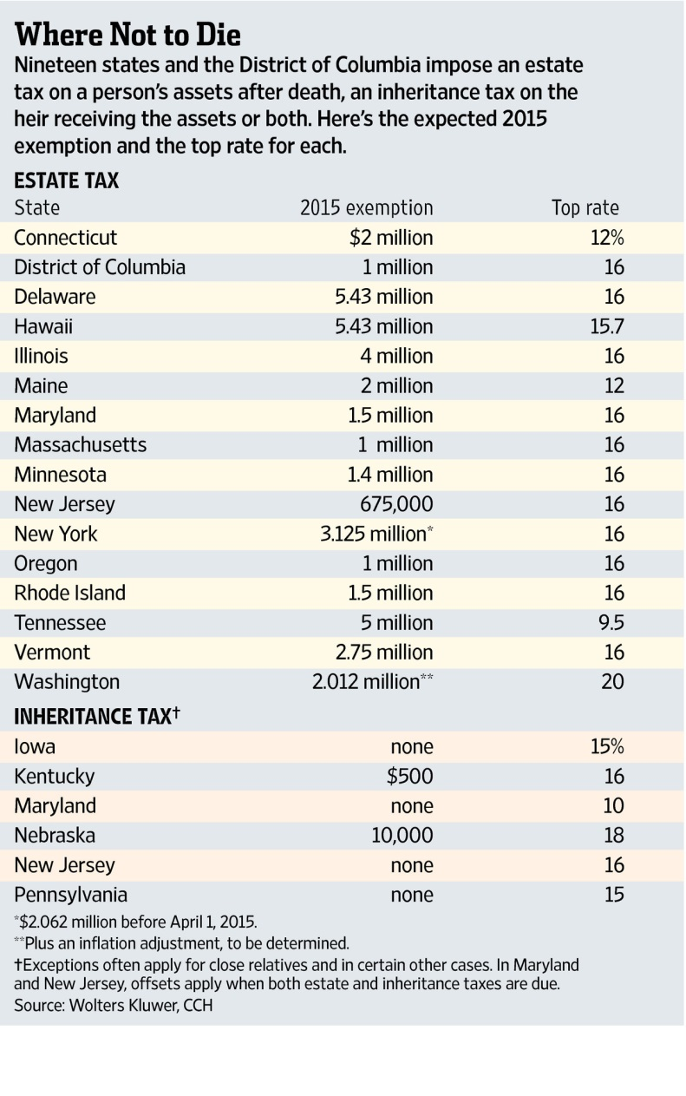

**Retirees need to plan for high healthcare costs**

According to Fidelity Investments, the average 65-year old couple will spend about $400,000 out-of-pocket throughout retirement until age 92, not including long-term care costs!

If you’re new to Medicare, you may find it’s more costly than anticipated. While Part A of traditional Medicare (covering hospital benefits) is free, you’ll pay income-adjusted premiums for Part B (covering outpatient services) and for Part D to get prescription-drug coverage. You may also opt for a private Medigap policy to help cover the costs that Medicare doesn’t cover.

**Financial Security Tip of the Month:**

If you are snapping photos of checks for electronic deposits into your bank account and have to retain your canceled check for a period of time prescribed by the bank, be sure to endorse the back of the check with “For mobile deposit only” to reduce chances of having the check negotiated at a bank before or after you’ve deposited it yourself.

*______________________________________________________________________________________________*

*Sources: Kiplinger’s Retirement Report, January 2015; 1Kiplinger Tax Letter, November 2014, Fidelity Investments,*

*Wall Street Journal, TheStreet.com*

**____________________________________________________________________________________________________________________________**

We hope you find the information in this newsletter useful, and always welcome your feedback.

Best regards,





Managing Shareholder

**4711 NW 53rd Avenue | Gainesville, FL 32653**

**Phone: (352) 373-1080 | Fax: (352) 373-5110 | www.mcdavidco.com**