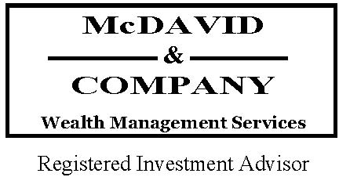 

__________________________________________________________________________________

**“Generous gestures yield the most when that is not their purpose.”** – Malcolm Forbes

___________________________________________________________________________________________________________________________

Using charitable trusts – on their own or in conjunction with donor-advised funds – may offer greater flexibility and control over charitable intentions in meeting philanthropic goals, while bolstering estate planning and tax management, enabling a donor to realize the joy of giving (not possible with a bequest).

A charitable trust allows a donor to set aside assets for one or more charities. There are two general types of charitable “split interest” trusts: charitable remainder trusts (CRTs) and charitable lead trust (CLTs). These types of trusts “split” the assets between charitable and non-charitable beneficiaries. Which type you choose depends on your priorities with respect to estate planning and wealth preservation, how you want the charity to receive the gift, and even the types of assets you wish to donate.

CRTs and CLTs are similar in that some of the assets go to one or more charities and some go to one or more non-charitable recipients. The key difference is when the charitable and non-charitable beneficiaries receive their payments. With a CLT, the charity receives an income interest for a term of years or for a person’s lifetime, with the individual(s) receiving the remaining assets at the end of the trust term.

Conversely, with a CRT, individuals receive the income interest, while one or more charities receive the remainder.

**Win – Win strategy for charities and donors**

In short, charitable trusts can preserve wealth for those with charitable intentions because they provide a tax-efficient method for giving, while increasing the social capital of the donor.



**Charitable Remainder Trust**

With a CRT, you donate certain assets – often highly appreciated or non-income producing – to the trust, which makes at least an annual payout back to you or to another non-charitable beneficiary for the term of the trust. You choose the time period, which can be for your or someone else’s lifetime or up to a 20-year term. When that time has expired, the remaining assets, as well as any appreciation generated, go to the charity or charities selected.

An advantage of using a CRT is that you can fund it with highly appreciated property, such as stock or real estate and sell those assets within the trust without paying capital gains taxes. Thus, the trust receives the full market value of the assets (undiluted by taxes), which translates into more money for both the charity and the non-charitable beneficiaries.

**Charitable Lead Trust**

A CLT makes at least an annual payout to the charity first. Then after a pre-determined period of time, the trust terminates and the remainder transfers to non-charitable beneficiaries, such as family members or a family trust. Offering flexibility similar to that of a CRT, the CLT allows the donor to choose the annual payout amount and the term of the trust – either a period of years or a person’s lifetime.

***Income tax deductions***

CRTs potentially provide immediate partial income tax deduction based on the value of the eventual gift to charity.

***Estate tax reductions***

Generally, once a CRT is funded, those assets are irrevocably excluded from the donor’s gross estate for estate tax purposes.

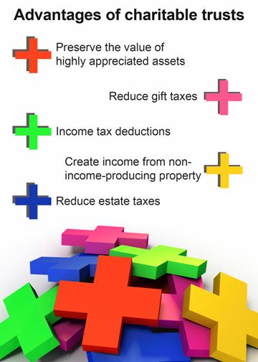

***Gift tax reductions***

Contributions to a CLT during your lifetime may qualify for gift tax deductions based on the interest eventually passing to the charity. However, if the remainder beneficiary of the CLT is not the original donor, then the donor might be subject to gift tax reporting on the value of the remainder interest. The rules are tricky, but there are ways to structure these non-grantor CLTs to potentially eliminate transfer taxes on the value passing to the end beneficiary.

***Creating income from non-income producing property***

CRTs can provide an income stream back to a donor who is charitably inclined, needs income, but owns non-income-producing property.

Alternatively, CRTs can be structured to delay the income stream paid to the donor until a future date, such as when another income stream terminates, or when the donor is in a lower tax bracket during retirement.

**Strategies to consider:**

* **Naming a donor-advised fund as the charitable beneficiary**

Using donor-advised funds in conjunction with your charitable trust offers flexibility to change your ultimate charitable recipients, rather than locking yourself in with a specific charity. With this strategy you not only retain flexibility in choosing or changing your mind on the charity, you may encourage family involvement, establishing a family legacy of giving.

* **Replacing assets for heirs**

If you plan to give substantial assets to charity but still want to provide additional resources for your heirs, you might consider using a CRT to help fund the purchase of life insurance. Donors may contemporaneously set up a CRT for charitable giving, and purchase life insurance (covering his or her life), using the income stream form the CRT to pay the life insurance premiums, with the death benefits payable to your heirs. If the life insurance policy is owned by the donor’s Irrevocable Life Insurance Trust, the value is also sheltered from estate taxes.

**CRUTs and CRATs – two flavors of CRTs**

A charitable remainder unitrust, or CRUT, ties the annual annuity payment to a percentage of the annually re-determined fair market value of the assets. Thus, the annual payout goes up each year the trust value increases, and goes down if the trust value decreases.

A charitable remainder annuity trust, or CRAT, sets the annual payments at a fixed percentage of the value of the originally donated assets.

**Pooled income trusts are a variation of CRTs**

in which donated assets are pooled among many donors and each donor receives income based on their portion of the overall investment pool, after which the remainder does to charity.

Pooled income trusts are established and administered by non-profit organizations. Thus, they provide a low-cost split-interest solution attracting donors whose gifts are not large enough to justify establishing individual CRUTs or CRATs, although they lock in the named charity.

**In terms of minimum gift thresholds:**

CRTs fall somewhere between the stratospheric giving levels of foundations – from $10 million to $20 million – and supporting organizations at $10 million,

to the downright affordable donor-advised funds at $10,000 or more,

and charitable gift annuities, from $10,000 to $25,000.

**The Fine Art of Planning With Collectibles**5

Collectibles are a very special asset class – one that requires expertise to analyze, value and incorporate as part of a larger advanced planning strategy.

Profitable sales of tangible personal property trigger a flat 28% long-term capital gains tax (in addition to potential Alternative Minimum Taxes and Net Investment Income Taxes – and possibly shifting the donor’s overall income into

a higher tax bracket on all other income) – while profitable sales of securities trigger a lower long-term capital gain tax rate up to a maximum 20% (albeit potentially triggering the same AMT and NIIT taxes as with collectibles).

The amount of income tax deductions allowed for art donations depends on several factors:

* The donor’s holding period and adjusted gross income
* Whether the gift represents a full and present interest
* Whether the charitable beneficiary is a qualified tax-exempt organization or a private foundation
* Whether the qualified charity uses art in furtherance of its tax-exempt purpose (as opposed to simply selling the donated art to generate more useful cash for the organization’s general purposes)

**Creative planning ideas:**

If a donor wants to gift art to a charity that doesn’t use art in its tax-exempt purpose, the charity sells the art, thus limiting the donor’s income tax deduction to the lower of cost or fair market value. However, there are sources available to make loans against qualified art, permitting the donor to make a fully deductible cash donation instead. Thus, the donor keeps the art to enjoy, and if properly structured, loan interest can roll into the loan or interest paid may be deducted as investment interest expense.

If the loan is paid off, the art can be transferred to a CRT. The art would be sold inside the CRT allowing a stream of income to the donor and leaving the principle to charity.

Alternatively, art can be gifted to a family foundation, which then *lends* it to a museum. Such a foundation confers multi-generational access to philanthropic capital. Fifty years after the death of a donor, great grandchildren may run the foundation (optionally with salaries) and glean personal connections to insights of great grandparents they never knew.

_________________________________________________________________________________________________________________________

Sources:

1*Charitable Giving that Gives Back,* FIDELITY VIEWPOINTS – 07/02/2015

2 *The nuts and bolts of charitable trusts,* Bankrate.com

3 *Charitable Gift Annuities: A Primer,* AICPA Wealth Management Insider

4 Lexisnexus.com

5  Lewis Schiff,*The Fine Art of Planning with Collectibles,* AICPA Wealth Management Insider

__________________________________________________________________________________________________________________________

Your trust and your family’s long term financial prosperity is our driving force. We appreciate the trust you have placed in us, and we are honored to serve as fiduciary stewards of your families’ and business’ long term wealth.

Best regards,





Managing Shareholder

**4711 NW 53rd Avenue | Gainesville, FL 32653 Phone: (352) 373-1080 | Fax: (352) 373-5110 www.mcdavidco.com**