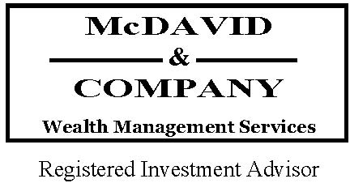 ________________________________________________________________________________________

**“Anyone can hold the helm when the sea is calm.”** – Unknown _______________________________________________________________________________

It’s a lot of fun when markets are rising and our statements show an increase each month. In fact we experienced the third longest such run in the past half century enjoying more than 1,400 days without even a 10% correction. In retrospect, we were long overdue for the sort of market pullbacks that began in late August.

Building sustainable wealth and financial success requires courage and commitment. Volatility in the market tests an investor’s resolution. As the saying goes, “anyone can hold the helm when the sea is calm,” but reactions in moments of fear or panic typically do not yield good results.

The best investors personify a successful mindset. They embrace a healthy relationship with respect to money and wealth-building principles. They recognize the enemy which is long-term purchasing power to sustain them through multiple-decades of retirement or to fund their legacy; and they seek their solution in equities, adding to their portfolios when the market offers them at a discount.

When the S&P 500 dropped 11% between August 17 and 25, some individual stocks like Apple (AAPL) fell as low as $92 from its trading price of $117 just a week earlier (dropping from a P/E ratio of 12 to 10.6). It was still the same Apple - just temporarily offered at a discount.1

Successful investors know the best way to participate in perpetual global economic growth and to build sustainable wealth is to be part owners of great companies whose products and services are demanded by consumers all over the world. [Think Procter & Gamble selling soap and diapers to worldwide markets].1

The stock market comprises real companies managing real assets, processes, patents and talents to sell profitably to growing markets of consumers with unquenchable thirst for products and services.

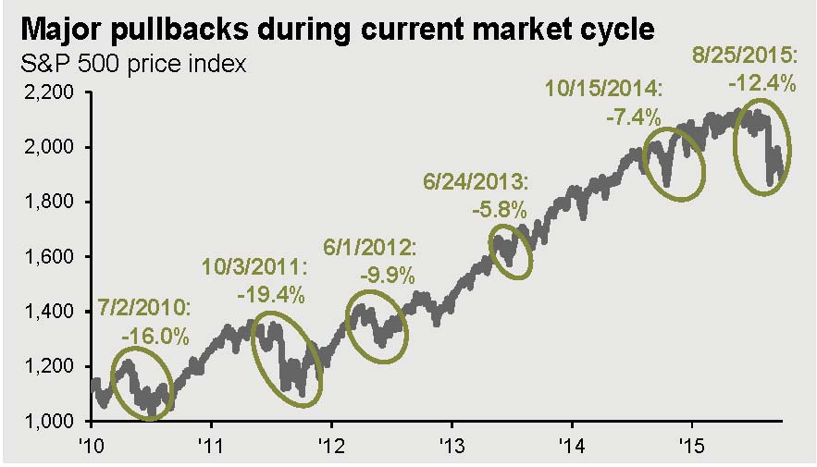

2

Assuming that investments incorporate informed analyses, the difficult challenge in owning equities is maintaining emotional composure under adverse conditions or during inevitable corrections. Although our financial goals could be graphed in a straight line, equity portfolios follow a bumpy ride on the up-escalator. (See graph above).

**Volatility Doesn’t Create Losses – Until You Sell** 3

As a primer: A “paper loss” is an unrealized capital loss in an investment – calculated by comparing the current market price of a security to the original purchase price. Losses only become realized when the security is sold.

Legendary buy-and-hold investor Warren Buffett was interviewed by CNBC amid the August market sell-off. When asked how it felt to have suddenly lost a sizable percentage of his lifetime accumulation of capital, he rhetorically responded by saying it felt about the same as it had the previous three times it happened.

⏺ Buffett suffered a paper loss of $347 million on October 19, 1987 – but he didn’t sell.

⏺ In the 45 days between July 17 and August 31, 1998, he suffered a paper loss of nearly $6.2 billion – but he didn’t sell.

⏺ Between the market peak of October 2007 and trough of March 2009, his paper loss totaled about $25 billion – but he didn’t sell.

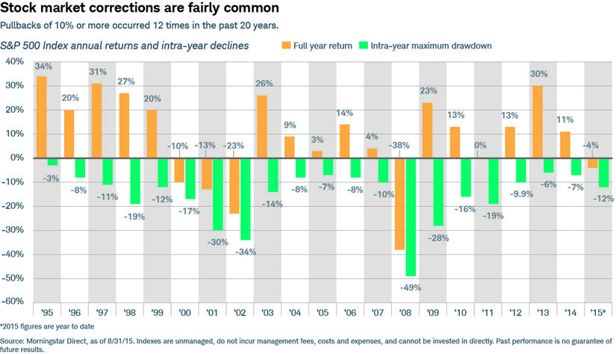

4

Benjamin Graham, economist, professional investor known as the father of value investing, and mentor to Warren Buffet pointed out that the day-to-day market isn’t a fundamental analyst; it’s a barometer of investor sentiment.

In today’s 24/7 financial news cycle, markets throw sudden and broad swings off global investors’ emotionally-driven activity.

As illustrated by the chart below, market corrections are normal and expected by seasoned equity investors – albeit the timing is not precisely predictable. Successful investors are not insulated from such volatility; but they train themselves to act as though they were.

**“You can observe a lot by just watching” pronounced the late, great Yogi Berra**

Huge sovereign debt obligations, decaying infrastructure, rising social welfare costs, Middle East conflicts and a dysfunctional government in Washington are all factors that weigh in on our macro-analyses. We are aware of the numerous serious long-term problems currently facing the world; however, they do not turn us bearish.

At times like these it’s fitting to point out the differences between ourselves from stock brokers and “robo-advisors.”

We do not believe that automated stop-loss transactions render an appropriate “safety-net” to minimize losses.

As fiduciaries, we are sensitive to the built-in transaction costs and personal tax implications of trades. As CPAs we have knowledge of your “big picture” including outside investments, estate goals, fluid financial circumstances, and even family dynamics.

We attempt to buy with margins of safety, believing purchase price is a major contributor to investment outcomes. For that reason we welcome normal market pullbacks for buying opportunities [Nick Murray, veteran investor, financial author and advisor to advisors called the August correction “a buy signal from God.”]

As wealth managers, we are not “active traders.” We do not place faith in generating consistent profits from continuous well-timed (lucky) buy and sell transactions as a way to build wealth. Rather, we believe that sustainable wealth is created by the things that you hold, and in making sound financial decisions through your accumulation years to your withdrawal years.

We feel it’s much safer to hold well-analyzed assets with strong fundamentals and attractive prices, in which case you can hold for a long time without necessarily needing to exit.

Perhaps the best defense against a lack of liquidity is arranging your financial affairs so there’s little need for it.

**Smart Money Moves:**

**Setting ourselves apart**

**Using a Roth IRA to pay for college**

Encourage your child to make Roth IRA contributions from teenage job earnings (better still, employ your child in your own business from an early age to supervise the savings plan).

The often overlooked Roth IRA enjoys a rather unique tax treatment. Withdrawals are treated as a “return of contribution” first and as earnings second. An individual who has contributed $5,000 per year for the past five years can withdraw $25,000 tax-free, to use the proceeds for qualified educational expenses.

[Withdrawals that exceed the total of one’s contributions -- and are attributable to earnings will be taxable for those under age 59 ½.]

But distributions from both traditional and Roth IRAs are exempt from the 10% early withdrawal penalties if the funds are used specifically for qualified educational expenses, including tuition, fees, books and room and board.

In contrast, any money saved for a child’s education in a 529 plan that is not used for educational expenses will not only become fully taxable as ordinary income but is also subject to a 10% penalty.

Unlike 529 plans, Roth IRAs permit funds not spent on education to be used for personal retirement.

(See the supplemental chart included at the end of our newsletter comparing the most popular college funding options. You can find more extensive details and useful information at this website: SavingForCollege.com).

**Using an HSA in Retirement**

Everyone is used to contributing to IRAs, 401(k)’s and defined benefit plans to fill a bucket for retirement income, but did you know that contributions to Health Savings Accounts may provide another tax-advantaged means to fill another financial bucket for your Golden Years?

HSA contributions permit a current income tax deduction similar to an IRA; HSAs name a beneficiary, benefit from tax-free growth, and distribute tax-free cash for medical expenses (possibly even for long-term care premiums), and many HSA plans permit investing the underlying assets similar to a self-directed IRA.

Keep abreast of annually-adjusted contribution limits and other eligibility criteria for participation in conjunction with a high-deductible health insurance plan until you are eligible for Medicare. [Note that a younger spouse may participate in an HSA to share his/her benefits with a Medicare-covered spouse.]

Here’s the kicker: If you opt to pay your medical expenses out of pocket and keep track of what you spent from personal funds, you may reimburse yourself later (even in retirement years) for those previous qualifying expenses. With the proper documentation, the cash flow from those reimbursements can be spent on anything you like, tax-free and penalty-free.



**Manage your tax brackets in retirement:** To effectively create “tax diversification” you’ll want to build a suite of taxable and nontaxable income sources at least five to 10 years prior to retirement. That way you’ll have the flexibility to pull withdrawals from different sources which are congruous with the fluctuating dynamics of your highly taxable (or tax-deductible) financial situation each year.

Depending on individual circumstances, Roth IRA distributions, Health Savings Account withdrawals, liquidations of taxable assets with unrealized losses (“tax loss harvesting”), tapping cash-value life insurance, short term flexible payment credit lines or reverse mortgages are examples of potentially non-taxable sources of cash flow.

_________________________________________________________________________________

Footnotes and Sources:

1 Specific companies named are not a recommendation to buy or sell at any particular time; they are merely named to illustrate a point.

2 FactSet, Standard & Poor’s, J.P. Morgan Asset Management Guide to the Markets – September 30, 2015.

3 OppenheimerFunds Blog, by Paul Blease and Brian Levitt – August 26, 2015

4 Graph from OppenheimerFunds Blog – August 26, 2015

_________________________________________________________________________________________________________

Your trust and your family’s long term financial prosperity is our driving force. We appreciate the trust you have placed in us, and we are honored to serve as fiduciary stewards of your families’ and businesses’ long term wealth.

We hope you find the information in this newsletter useful, and always welcome your feedback.

Best regards,





